**Flow Diagrams**

## Section 1: Review of Overall Structure

As discussed before this is what the overall structure looks like. Visitar is the product you are building for me. I will be selling this product, and I will be the VISITAR Admin using the Top Level VISITAR Admin Portal.

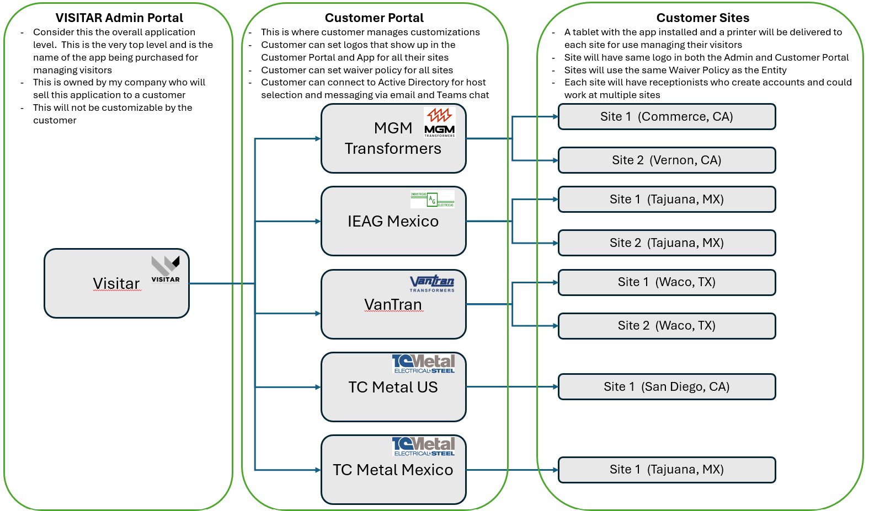

## Section 2: Detailed Flow

This flow diagram shows what the various Users will do and what portal/app they will access to do it. Please review this in detail to make sure you understand the flow and why we need to make a few changes.

